Changes

At fist of all, I want to focus on the design part. In the process of making our website, we found that the original mobile interface design was not very good. Originally, we decided to display three icons side by side on the welcome page, but later found that this would make the structure too compact and unsightly, and the same leaf appeared in the same on the portal.

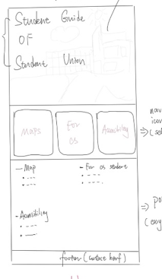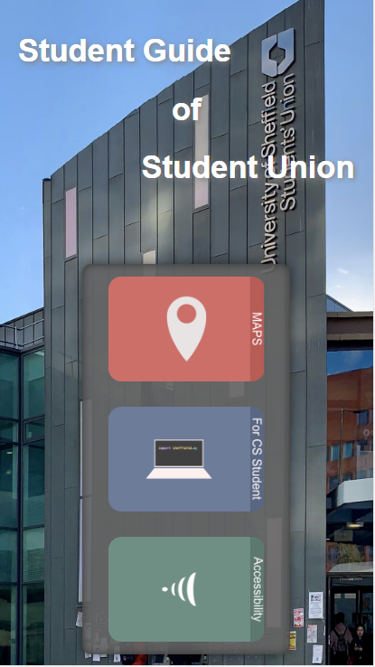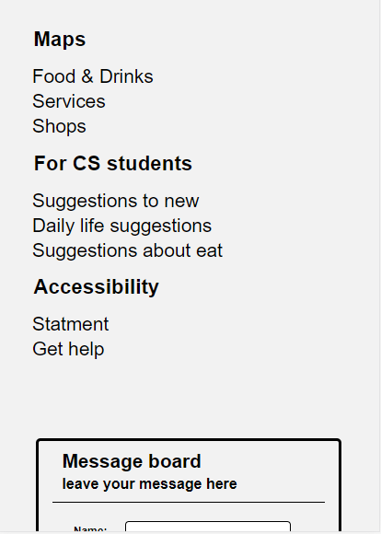

**Original Now**

Then we put the message board that was originally placed on the contact page on the welcome page (this is the thing in the picture) because we found the welcome page to be a bit monotonous and doing so helps us get more user messages.

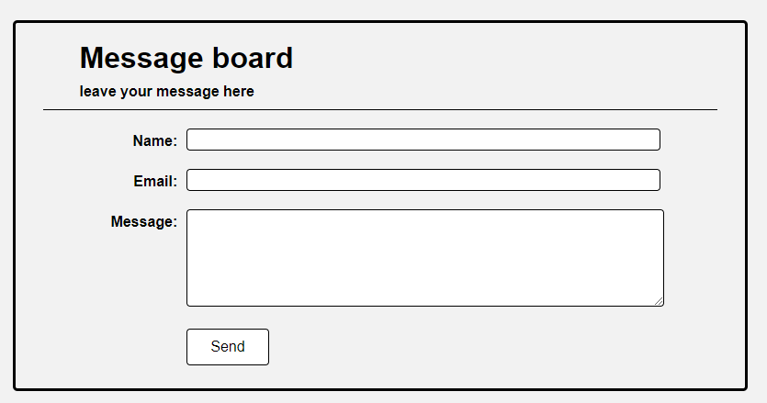

Organisation:

Optimisation:

On all the images on the site (including jpg and png) we used progressive image loading. This allows the image loading process to be displayed and enhances the user experience.

Security:

Testing:

In the test we used the chrome browser developer tool, using the device simulator in it to complete our website testing on different devices.